**DC Motor Driver Circuit: Technical Report**

Name: Muhammad Saifuddin

**Table of Figures**

Figure 1: H-Bridge Motor Driver circuit diagram 8

Figure 2: 555-timer for PWM circuit diagram 8

Figure 3: Optical Encoder circuit diagram 9

Figure 4: H-Bridge current flow explanation 9

Figure 5: H-Bridge sample circuit schematic 10

Figure 6: H-Bridge, voltage drop across motor shown to be positive 11

Figure 7: H-Bridge, voltage drop across motor is shown to be negative 12

Figure 8: Oscilloscope of PWM generator minimum frequency 13

Figure 9: Oscilloscope of PWM generator maximum frequency 13

Figure 10: Oscilloscope of Optical Encoder during arbitrary duty cycle and frequency 14

Figure 11: H-Bridge built on breadboard 15

Figure 12: H-Bridge circuit built on breadboard (different view) 16

Figure 13: 555-timer circuit built on breadboard (top view) 17

Figure 14: 555-timer circuit built on breadboard (side view) 18

Figure 15: Optical Encoder circuit built on breadboard 19

Figure 16: Final complete circuit (top view) 20

Figure 17: Final complete circuit (side view) 21

**Problem Statement**

The purpose of building the motor driver circuit is to have the ability to control the speed and direction of a dc motor.

**Circuit Design**

The circuit that was used for the motor driver was an H-Bridge circuit, its implementation can be seen in Figure 1. This circuit is mainly comprised of two different types of transistors, a N-FET and a P-FET; together they work in a simple manner. Essentially, when voltage is applied at the gate of a N-FET it is in ‘ON’ mode, and in ‘OFF’ mode when no voltage is applied (P-FETs work in the opposite manner, no voltage: ‘ON’ , voltage: ‘OFF’) refer to Figure 4 for further clarification. This allows us to chance the polarity of the voltage across the dc motor, thus, allowing for direction control (when SPDT is thrown, SPDT is a single pole double throw switch). A single 9V battery is needed to power the circuit and it ranges from -9V to 9V.

The circuit that was used to generate the PWM function is the 555-timer circuit, its implementation can be seen in Figure 2. A single NE555P is used and acts like an astable electronic oscillator. The duty cycle is controlled using a 5kΩ potentiometer, the range of the duty cycle is 51% to 95% and the range if the frequency is 15Hz to 29Hz. A single 9V battery is enough to power the circuit and it ranges from 0V to 9V.

The last circuit is an optical encoder, it uses a phototransistor along with a spinning disk to measure the speed of the dc motor. A single 9V battery is needed to power the circuit and it ranges from 0V to 9V.

**Construction & Testing Methodology**

Motor Driver: H-Bridge

The H-bridge was implemented in the final design. Building it initially, it was done looking at a sample circuit schematic, refer to Figure 5. The circuit was built with the N-FETs at the top and the P-FETS at the bottom, in this order the terminals were connected as dssd (drain, source, source, drain). The resistor values were chosen arbitrarily as long as they were a large value to allow the least amount of current to pass through; two 10kΩ resistors were used. After building the sample circuit the multimeter was used to determine if there was a voltage across the motor, no voltage drop was recorded. There may have been a problem with the overall wiring of the sample circuit. However, this was disassembled and recreated in the opposite manner P-FETS at the top and the N-FETS at the bottom, because after doing some research some circuit schematics wired it sdds (source, drain, drain, source) meaning the transistors were switched in their order. After rebuilding, there was a voltage drop across the motor and when the switch was thrown the polarity was shown to change, refer to Figure 6 and 7. This ensures that the H-Bridge works and is able to control the direction of the motor. Refer to Figure 11 and 12 for the implemented circuit on a breadboard.

PWM Function Generator: 555-timer IC

To determine the resistors and capacitor values for the 555-timer circuit the oscilloscope function generator was used to run the motor to determine the appropriate frequency and duty cycle, which would allow to simply calculate the resistors and capacitor values. After doing so, it was found that a duty cycle from 50% to 90% would work well, along with a frequency of 12Hz to 30Hz.

To find a duty cycle of around 50% to 90%, we know

$$0.5= \frac{R_{1}}{R_{1}+R_{2}}$$

This ratio must be half to get the desired duty cycles, with some trial and error, values for the resistances can be found. Assume $R_{1}=4.7kΩ$ and $R_{2}=27kΩ$ and 5 kΩ potentiometer with 220Ω.

$$R_{2}=(R_{2}||(5kΩ+220Ω)$$

$$R_{2}=4.37kΩ$$

$$0.5≅ \frac{4.7kΩ}{4.7kΩ+4.37kΩ}=0.52$$

Then we can also confirm that the other end of the duty cycle ($η_{max})$

$$R_{2}=(R_{2}||(0kΩ+220Ω)$$

$$R_{2}=0.218kΩ$$

$$0.9≅ \frac{4.7kΩ}{4.7kΩ+0.218kΩ}=0.955$$

To confirm frequencies, solve for $t_{high} and t_{low}$. Also assume C equal to large value, $C=10μF$.

$$t_{high}=R_{1}Cln2$$

$$t_{high}=0.0326$$

$$t_{high}f_{max}=η_{max}$$

$$f_{max}=\frac{0.9556}{0.0326}=29.31≅30$$

This same process was done (using $t_{low}=R_{2}Cln2$) to confirm the value of $f_{min}$

$$f_{min}=17.10≅12$$

Confirming the values of the resistors and capacitors we can build the PWM generator. Constructing the circuit is a simple task as it is not a complex circuit. Refer to Figure 8 and 9 for max and min frequencies and duty cycle. Refer to Figure 13 and 14 for the circuit built on the breadboard.

Optical Encoder:

To build this circuit an old circuit schematic was used, this is the same circuit diagram in Figure 10. Using the optical encoder along-side the other two circuits, an oscilloscope trace can be found. Refer to Figure 15 for the circuit built on the breadboard.

The Final Complete Circuit

Refer to Figure 16 and 17 for pictures of the final complete circuit. I have attached a short 30 second video clip of the final complete circuit working.

**Parts List**

|  |  |  |
| --- | --- | --- |
| **Component** | **Quantity** | **Description** |
| Resistors | 2 | 10kΩ |
|  | 1 | 1kΩ |
|  | 1 | 27kΩ |
|  | 1 | 4.7kΩ |
|  | 1 | 220Ω |
|  | 1 | 470Ω |
| Capacitors | 1 | 4.7nF |
|  | 1 | 10uF |
| Diodes | 1 | 1N4148 Signal Diodes |
| Integrated Circuits | 1 | NE555-P Timer IC |
| Transistors | 2 | IRFD9020 P-FET |
|  | 2 | VN3205 N-FET |
|  | 1 | QSE133 Phototransistor |
| Electromechanical | 1 | SPDT |
|  | 1 | ARM Cortex-9 Microprocessor |
| DC Motor | 1 | 125 RPM |
| IR LED | 1 | WP7113F3BT |
| RED LED | 2 | C5SMF-RJF-CT0W0BB1 |

**

Figure 1: H-Bridge Motor Driver circuit diagram

Figure 2: 555-timer for PWM circuit diagram

Figure 3: Optical Encoder circuit diagram

Figure 4: H-Bridge current flow explanation

Figure 5: H-Bridge sample circuit schematic

Figure 6: H-Bridge, voltage drop across motor shown to be positive

Figure 7: H-Bridge, voltage drop across motor is shown to be negative

Figure 8: Oscilloscope of PWM generator minimum frequency

Figure 9: Oscilloscope of PWM generator maximum frequency

Figure 10: Oscilloscope of Optical Encoder during arbitrary duty cycle and frequency

Figure 11: H-Bridge built on breadboard

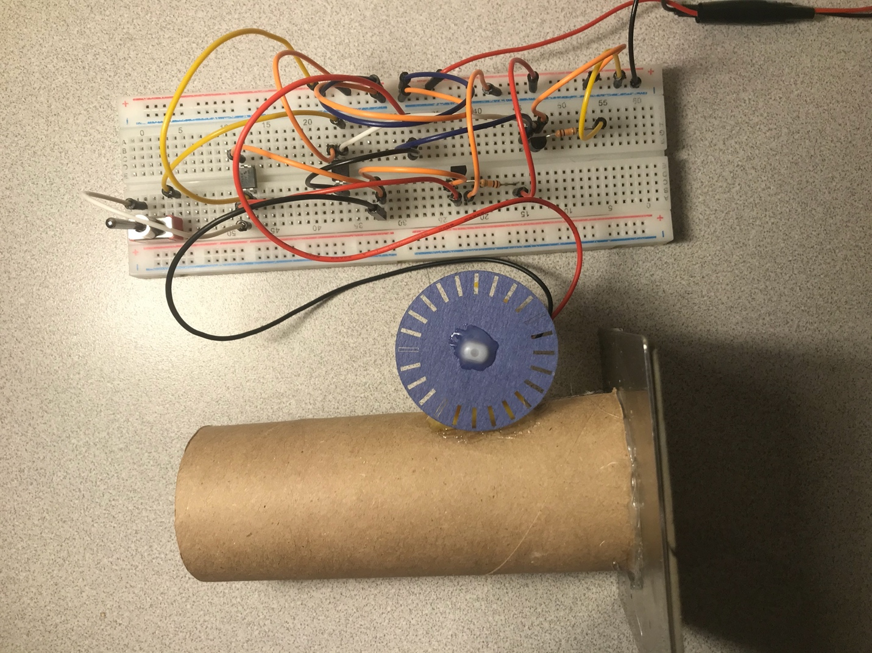

Figure 12: H-Bridge circuit built on breadboard (different view)

Figure 13: 555-timer circuit built on breadboard (top view)

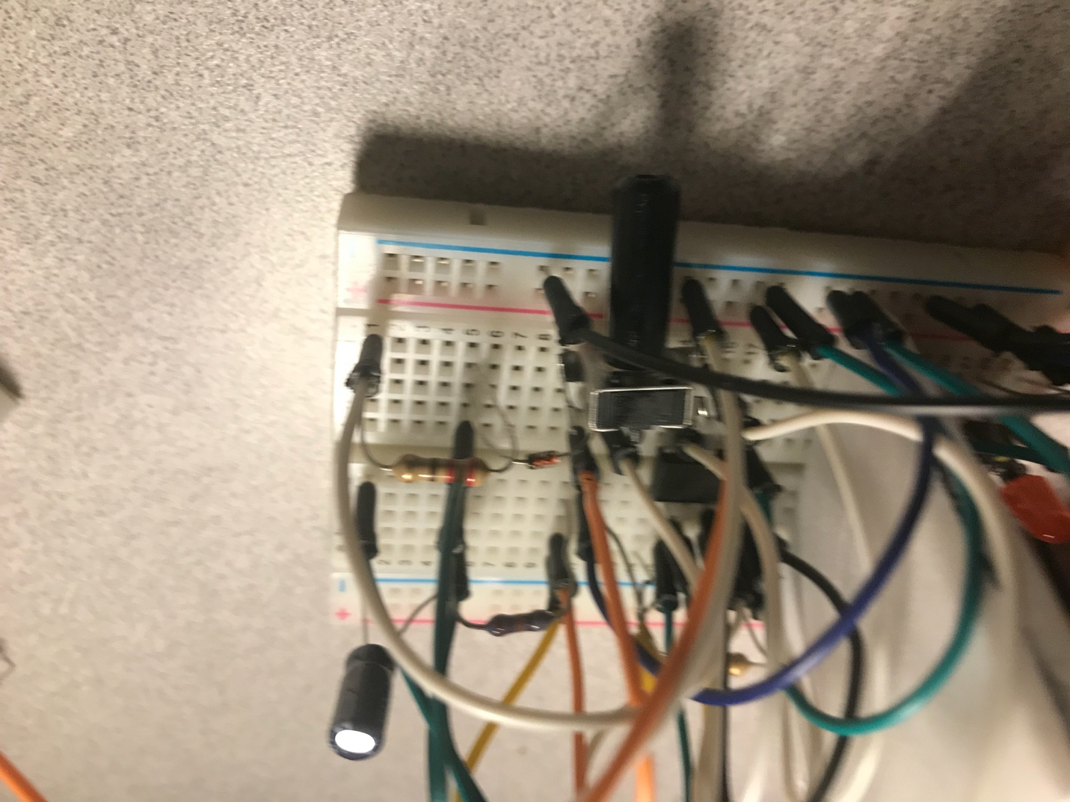

Figure 14: 555-timer circuit built on breadboard (side view)

Figure 15: Optical Encoder circuit built on breadboard

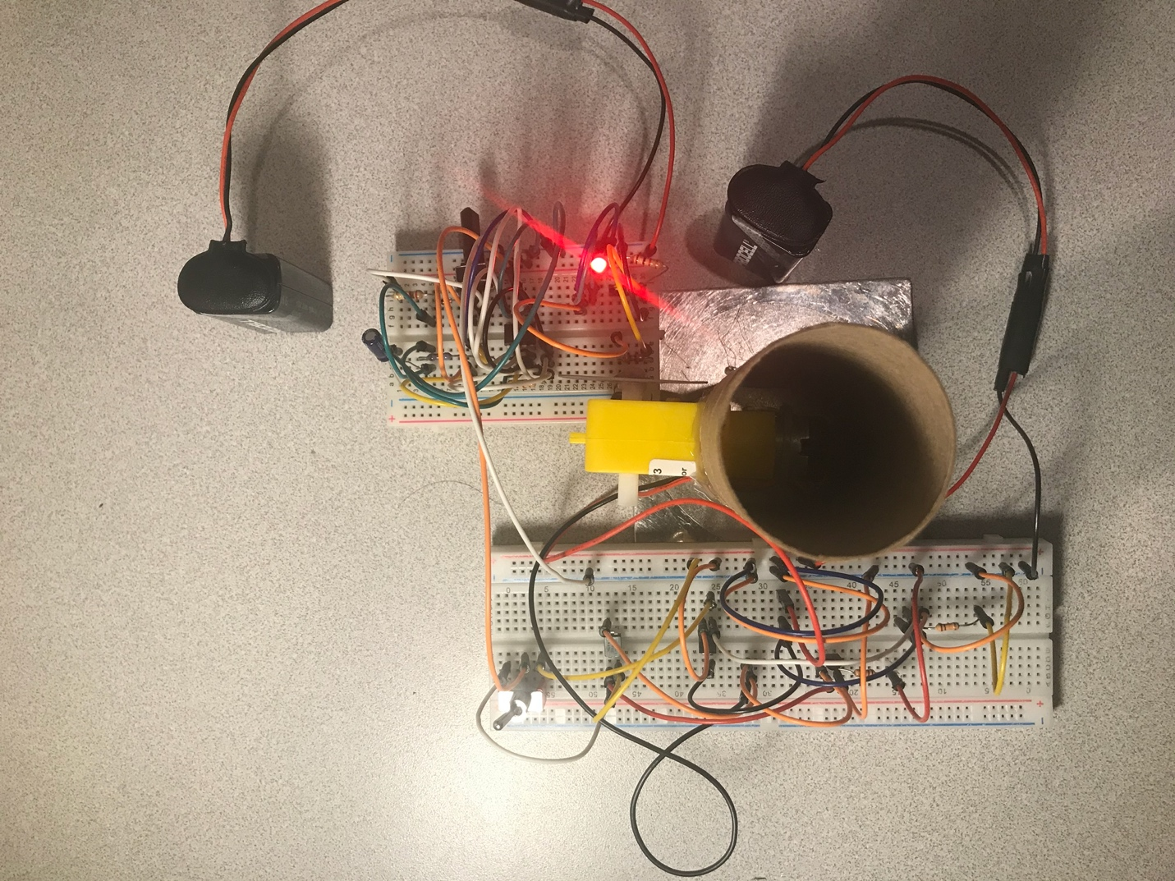

Figure 16: Final complete circuit (top view)

Figure 17: Final complete circuit (side view)